## **ProblemStatement:**

Recreate the table as shown in the image.

1.

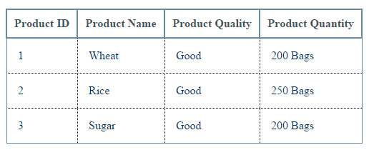

2.

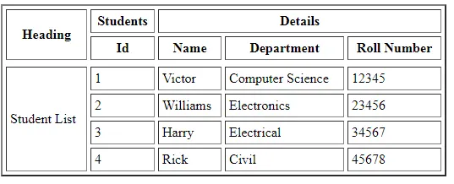

Ensure that the text and the perfect squares are displayed in bold text.

**Problem Statement:**

Create Layouts like the images below?

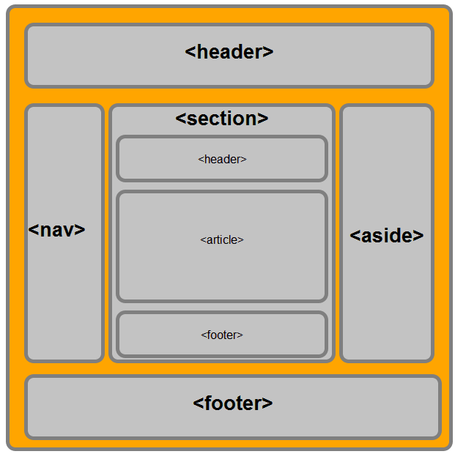

2.

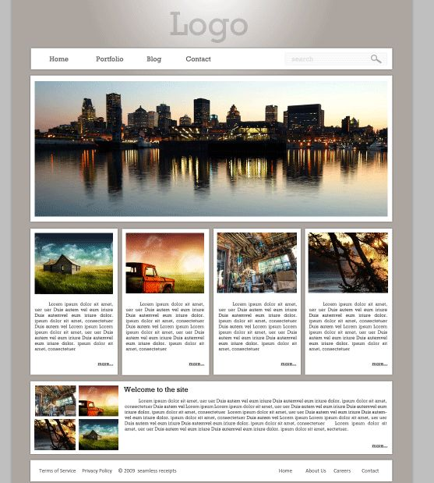

## **ProblemStatement:**

Recreate the Form as shown in the image.

1.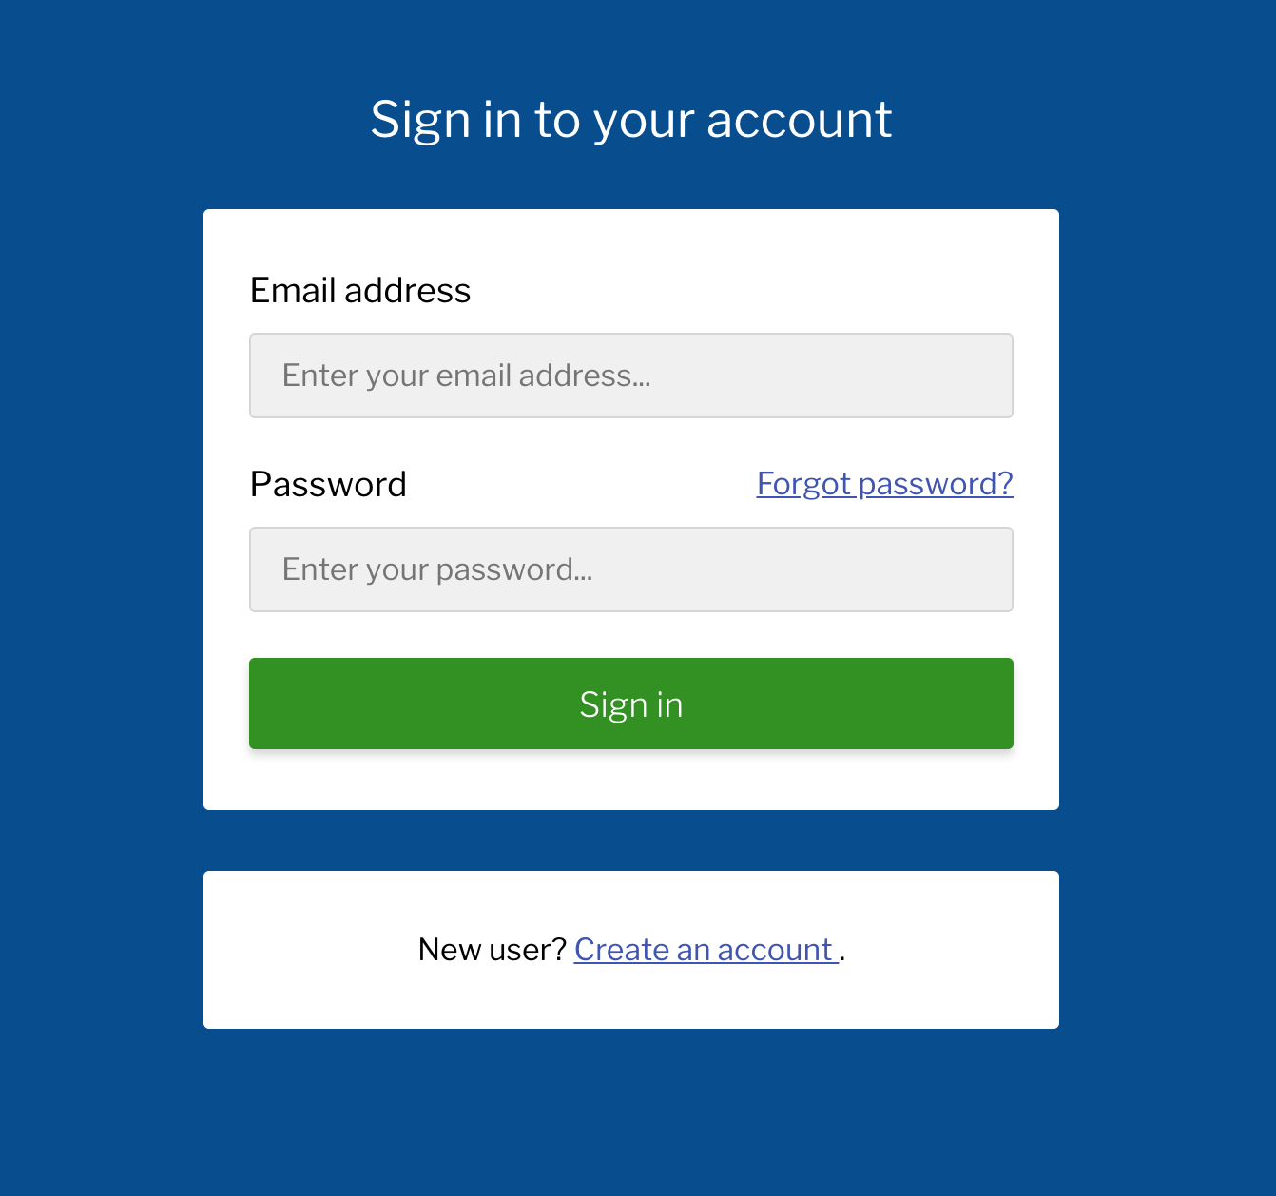

2.

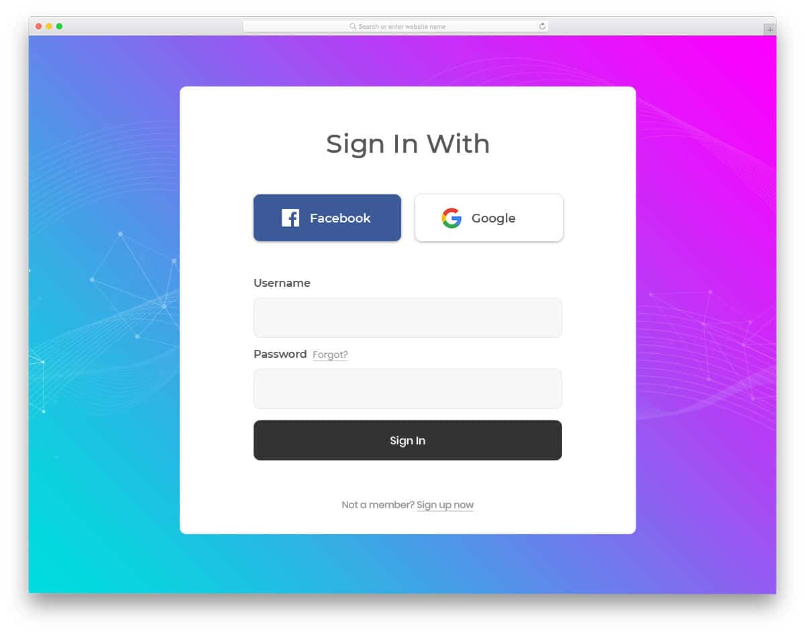

3.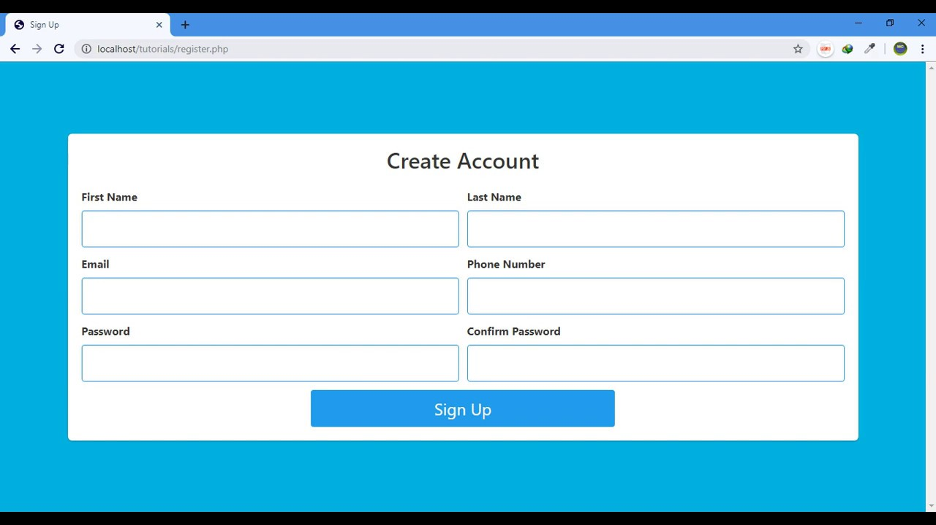

4.